Constructing Regular Decagon

Definition
# Source: AI Source: Provided by: [Data Path: Persons Table -> ID Column: 1, Name_En Column: Motasem Essam] -> From: [ChatGPT] on [7/25/2026]
A regular decagon is a polygon with 10 equal sides and 10 equal interior angles.
For a regular decagon:
$$\boxed{n=10} \\ \boxed{AB=BC=CD=DE=EF=FG=GH=HI=IJ=JA}$$
All interior angles are equal, and all central angles are equal.

Fundamental Properties
# Source: AI Source: Provided by: [Data Path: Persons Table -> ID Column: 1, Name_En Column: Motasem Essam] -> From: [ChatGPT] on [7/25/2026]
Number of Sides
$$\boxed{10}$$
Number of Vertices
$$\boxed{10}$$
Interior Angle
$$\boxed{\frac{\left(10-2\right){180}^{∘}}{10}={144}^{∘}}$$
Sum of Interior Angles
$$\boxed{\left(10-2\right){180}^{∘}={1440}^{∘}}$$
Central Angle
A complete circle is divided into 10 equal parts:
$$\boxed{\frac{{360}^{∘}}{10}={36}^{∘}}$$
Therefore, each central angle is:
$$\boxed{{36}^{∘}}$$
Exterior Angle
$$\boxed{{36}^{∘}}$$
For a regular polygon, each exterior angle equals its central angle.

Constructing a Regular Decagon
# Source: AI Source: Provided by: [Data Path: Persons Table -> ID Column: 1, Name_En Column: Motasem Essam] -> From: [ChatGPT] on [7/25/2026]
Unlike the regular heptagon and regular nonagon, a regular decagon can be constructed exactly using an unmarked straightedge and compass.
This is because:
$$10=2×5$$
and both the regular pentagon and the regular decagon satisfy the classical constructibility conditions.
A particularly convenient construction uses a regular pentagon construction or a circumcircle divided into ten equal central angles.

Construction From a Circumcircle
# Source: AI Source: Provided by: [Data Path: Persons Table -> ID Column: 1, Name_En Column: Motasem Essam] -> From: [ChatGPT] on [7/25/2026]
Steps
- Draw a circle with center $O$.
- Construct a diameter $AC$.
- Construct a perpendicular diameter through $O$.
- This divides the circle into four ${90}^{∘}$quadrants.
- Bisect the appropriate ${60}^{∘}$- or ${72}^{∘}$-based construction angles to obtain ${36}^{∘}$central divisions.
- Mark ten equally spaced points on the circle.
- Label them:
$$A,B,C,D,E,F,G,H,I,J$$
- Connect consecutive vertices.
The result is a regular decagon.
A more direct exact method is to construct a regular pentagon and then bisect each of its central ${72}^{∘}$angles:
$$\frac{{72}^{∘}}{2}={36}^{∘}$$
This produces the ten vertices of the regular decagon.

Construction From a Regular Pentagon
# Source: AI Source: Provided by: [Data Path: Persons Table -> ID Column: 1, Name_En Column: Motasem Essam] -> From: [ChatGPT] on [7/25/2026]
A regular decagon can be constructed by starting with a regular pentagon inscribed in a circle.
The pentagon has central angles:
$${72}^{∘}$$
Bisect each central angle:
$$\boxed{{72}^{∘}÷2={36}^{∘}}$$
Each original pentagon side is therefore divided into two equal circular arcs, producing five additional vertices.
Thus:
$$\boxed{\text{Regular Pentagon}+\text{Central-Angle Bisection}→\text{Regular Decagon}}$$

Construction From a Given Side
# Source: AI Source: Provided by: [Data Path: Persons Table -> ID Column: 1, Name_En Column: Motasem Essam] -> From: [ChatGPT] on [7/25/2026]
If the side length is $s$, the circumradius $R$is:
$$\boxed{R=\frac{s}{2\sin{{18}^{∘}}}}$$
Since:
$$\sin{{18}^{∘}}=\frac{\sqrt{5}-1}{4}$$
we obtain:
$$\boxed{R=\frac{s}{\sqrt{5-\sqrt{5}}}}$$
The apothem $a$is:
$$\boxed{a=\frac{s}{2\tan{{18}^{∘}}}}$$

Construction From a Given Circumradius
# Source: AI Source: Provided by: [Data Path: Persons Table -> ID Column: 1, Name_En Column: Motasem Essam] -> From: [ChatGPT] on [7/25/2026]
If the circumradius is $R$, the side length is:
$$\boxed{s=2R\sin{{18}^{∘}}}$$
or:
$$\boxed{s=\frac{\sqrt{5}-1}{2}R}$$
The quantity
$$\frac{\sqrt{5}-1}{2}$$
is the reciprocal of the golden ratio.

Mathematical Properties
# Source: AI Source: Provided by: [Data Path: Persons Table -> ID Column: 1, Name_En Column: Motasem Essam] -> From: [ChatGPT] on [7/25/2026]
Side Length
$$\boxed{s=2R\sin{{18}^{∘}}}$$
Circumradius
$$\boxed{R=\frac{s}{2\sin{{18}^{∘}}}}$$
Apothem
$$\boxed{a=\frac{s}{2\tan{{18}^{∘}}}}$$
Perimeter
$$\boxed{P=10s}$$
Area
Using:
$$A=\frac{1}{2}Pa$$
we obtain:
$$\boxed{A=5sa}$$
In terms of the side length:
$$\boxed{A=\frac{5s^{2}}{2\tan{{18}^{∘}}}}$$

Symmetry
Lines of Symmetry
A regular decagon has:
$$\boxed{10}$$
lines of symmetry.
There are two types:
- 5 axes passing through opposite vertices.
- 5 axes passing through the midpoints of opposite sides.
Rotational Symmetry
The rotational symmetry has order:
$$\boxed{10}$$
The smallest non-zero rotation is:
$$\boxed{{36}^{∘}}$$
Therefore, rotations through multiples of ${36}^{∘}$map the decagon onto itself.

Diagonals
A decagon has:
$$\boxed{\frac{n\left(n-3\right)}{2}}$$
diagonals.
For $n=10$:
$$\frac{10\left(10-3\right)}{2}=\frac{70}{2}=\boxed{35}$$
So a regular decagon has 35 diagonals.

Types / Construction Situations
# Source: AI Source: Provided by: [Data Path: Persons Table -> ID Column: 1, Name_En Column: Motasem Essam] -> From: [ChatGPT] on [7/25/2026]
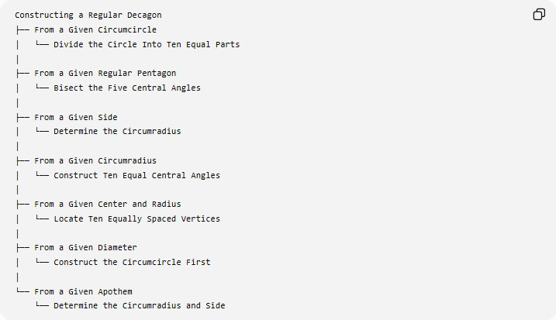
Constructing a Regular Decagon
├── From a Given Circumcircle
│ └── Divide the Circle Into Ten Equal Parts
│
├── From a Given Regular Pentagon
│ └── Bisect the Five Central Angles
│
├── From a Given Side
│ └── Determine the Circumradius
│
├── From a Given Circumradius
│ └── Construct Ten Equal Central Angles
│
├── From a Given Center and Radius
│ └── Locate Ten Equally Spaced Vertices
│
├── From a Given Diameter
│ └── Construct the Circumcircle First
│
└── From a Given Apothem
└── Determine the Circumradius and Side
Classification note: these represent different construction situations, not different mathematical types of regular decagons.

Basic Constructions Used
# Source: AI Source: Provided by: [Data Path: Persons Table -> ID Column: 1, Name_En Column: Motasem Essam] -> From: [ChatGPT] on [7/25/2026]
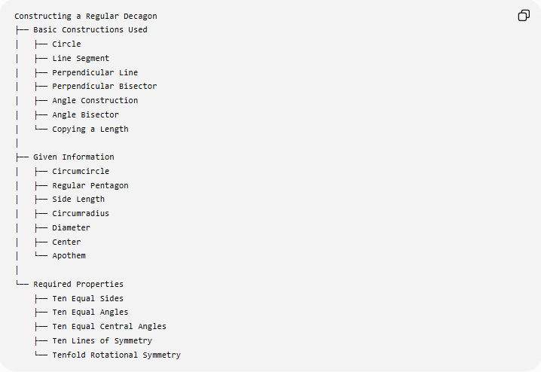
Constructing a Regular Decagon
├── Basic Constructions Used
│ ├── Circle
│ ├── Line Segment
│ ├── Perpendicular Line
│ ├── Perpendicular Bisector
│ ├── Angle Construction
│ ├── Angle Bisector
│ └── Copying a Length
│
├── Given Information
│ ├── Circumcircle
│ ├── Regular Pentagon
│ ├── Side Length
│ ├── Circumradius
│ ├── Diameter
│ ├── Center
│ └── Apothem
│
└── Required Properties
├── Ten Equal Sides
├── Ten Equal Angles
├── Ten Equal Central Angles
├── Ten Lines of Symmetry
└── Tenfold Rotational Symmetry

Classification in Geometric Construction
# Source: AI Source: Provided by: [Data Path: Persons Table -> ID Column: 1, Name_En Column: Motasem Essam] -> From: [ChatGPT] on [7/25/2026]
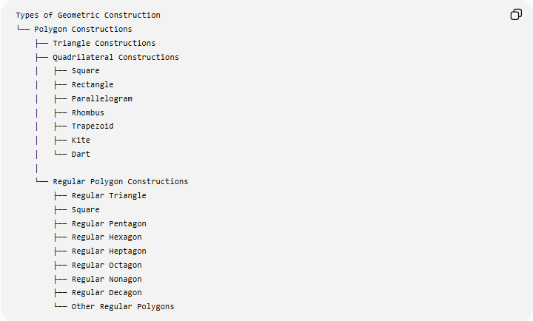
Types of Geometric Construction
└── Polygon Constructions
├── Triangle Constructions
├── Quadrilateral Constructions
│ ├── Square
│ ├── Rectangle
│ ├── Parallelogram
│ ├── Rhombus
│ ├── Trapezoid
│ ├── Kite
│ └── Dart
│
└── Regular Polygon Constructions
├── Regular Triangle
├── Square
├── Regular Pentagon
├── Regular Hexagon
├── Regular Heptagon
├── Regular Octagon
├── Regular Nonagon
├── Regular Decagon
└── Other Regular Polygons

Comparison With Nearby Regular Polygons
# Source: AI Source: Provided by: [Data Path: Persons Table -> ID Column: 1, Name_En Column: Motasem Essam] -> From: [ChatGPT] on [7/25/2026]
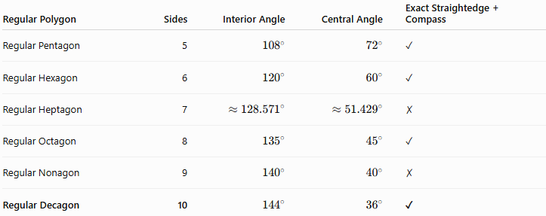
Regular Polygon | Sides | Interior Angle | Central Angle | Exact Straightedge + Compass
Regular Pentagon | 5 | $${108}^{∘}$$ | $${72}^{∘}$$ | ✓
Regular Hexagon | 6 | $${120}^{∘}$$ | $${60}^{∘}$$ | ✓
Regular Heptagon | 7 | $$≈{128.571}^{∘}$$ | $$≈{51.429}^{∘}$$ | ✗
Regular Octagon | 8 | $${135}^{∘}$$ | $${45}^{∘}$$ | ✓
Regular Nonagon | 9 | $${140}^{∘}$$ | $${40}^{∘}$$ | ✗
Regular Decagon | 10 | $${144}^{∘}$$ | $${36}^{∘}$$ | ✓
The regular decagon is therefore an important contrast with the regular nonagon: 10 sides are exactly constructible with classical straightedge and compass, while 9 sides are not.

Key Points
# Source: AI Source: Provided by: [Data Path: Persons Table -> ID Column: 1, Name_En Column: Motasem Essam] -> From: [ChatGPT] on [7/25/2026]
- A regular decagon has 10 equal sides.
- It has 10 equal interior angles.
- Each interior angle is:
$$\boxed{{144}^{∘}}$$
- The sum of its interior angles is:
$$\boxed{{1440}^{∘}}$$
- Each central angle is:
$$\boxed{{36}^{∘}}$$
- It has 10 lines of symmetry.
- It has rotational symmetry of order 10.
- Its perimeter is:
$$\boxed{P=10s}$$
- Its area is:
$$\boxed{A=5sa}$$
- It has:
$$\boxed{35}$$
diagonals.
- It can be constructed exactly using an unmarked straightedge and compass.
- A convenient construction is to construct a regular pentagon and bisect each ${72}^{∘}$central angle.

Conclusion
# Source: AI Source: Provided by: [Data Path: Persons Table -> ID Column: 1, Name_En Column: Motasem Essam] -> From: [ChatGPT] on [7/25/2026]
A regular decagon is a ten-sided regular polygon with equal sides, equal angles, a central angle of ${36}^{∘}$, and an interior angle of ${144}^{∘}$. It has 10 lines of symmetry, rotational symmetry of order 10, and 35 diagonals. Most importantly for geometric construction, the regular decagon is exactly constructible with straightedge and compass, making it different from the regular heptagon and regular nonagon.

